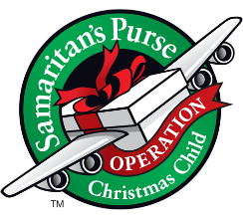
OPERATION
CHRISTMAS CHILD 2019

Packing Party – Sunday, November 10th
3pm downstairs in Van Wyk Hall

Checklist of Needed Items
- Wrapped individual toothbrush
- Bar of soap in plastic bag
- Comb and/or brush/caps/hats
- Hair clips/accessories/jewelry/sunglasses/flip-flops
- Small stuffed animal/doll
- Crayons, markers, or colored pencils
- Pens and pencils/erasers/pencil sharpener/rulers/solar calculators
- Paper (notebook/drawing)
- Coloring book (young child)
- Story book
- Small toys/games (toys cars, trains, yo-yo’s, flashlights, airplanes, beads, puzzles, etc.)
- Stickers
- Washcloths
- Package of underwear/socks/t-shirts
- Box Wrapped (lid separately), labeled, rubber band

Monetary donations will also be accepted for shipping costs ($9 per box) and purchases of needed items.

*Kindly ensure that all items are newly purchased.
*Do NOT include war related items such as guns, knives, or military figures, chocolate or food items, candy, toothpaste, lotions/liquids, or breakable items such as mirrors, snow globes, breakable mugs, glasses, etc.

